IW-17
YEAR 9 SCIENCE
PHYSICAL SCIENCES
LIGHT AND HEAT TEST (MODIFIED)

NAME: CLASS: Mark: $\frac{}{\text{34}}$

QUESTION | ANSWER
1
2
3
4
5
6
7
8
9
10
11
12
13
14
15
16
17
18
Multiple Choice Write the answer to each question in the appropriate box at right.

1. The electromagnetic energy we feel as heat is:

(a) infrared.
(b) ultraviolet.
(c) microwave.
(d) radio.

2. Which of the following measures the wavelength of a transverse wave?

(a) The distance between the top of a crest and bottom of a trough.
(b) The distance of the top of a crest above the bottom of a trough.
(c) The distance from the start of a wave to its end.
(d) The distance between the tops of two troughs.

3. Which of the following statements best describes the motion of particles in a transverse wave?

(a) The particles vibrate parallel to the direction of energy transfer.
(b) The particles vibrate at right angles to the direction of energy transfer.
(c) The particles gradually spread out parallel to the direction of energy transfer.
(d) The particles gradually spread out at right angles to the direction of energy transfer.

4. Refraction of light is:

(a) the wave motion of light as it passes through a substance.
(b) the bending of light as it passes from one substance into another.
(c) a reflection of light rays at the surface of a medium.
(d) the failure of light to pass through a very dense substance.

5. Light travels in lines.

(a) diagonal
(b) curved
(c) horizontal
(d) straight

6. The greater the curvature of a convex lens:

(a) the more it bends light and hence the shorter the focal length.
(b) the more it bends light and hence the longer the focal length.
(c) the less it bends light and hence the shorter the focal length.
(d) the less it bends light and hence the longer the focal length.

7. Mirrors will light rays.

(a) scatter
(b) refract
(c) transmit
(d) reflect

8. Refraction can make it difficult to judge the depth of water. How is the light shown from the point in the diagram bent?
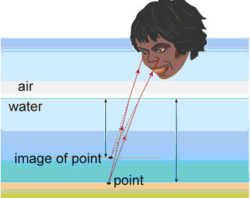

(a) Light from the point is bent towards the normal, making the point seem deeper.
(b) Light from the point is bent away from the normal, making the point seem shallower.
(c) Light from the point is bent towards the normal, making the point seem shallower.
(d) Light from the point is bent away from the normal, making the point seem deeper.

9. A man has a black patch over his right eye. He looks into a plane mirror. Which of the following diagrams best describes the image he sees?

 | (a) | 
 | (b) | 
 | (c) | 
 | (d) | 

10. Identify the correct statement about reflection of light.

(a) The angle of incidence equals the angle of refraction.
(b) The reflective coating is commonly placed on the back surface of a plane mirror.
(c) The law of reflection only applies to plane mirrors.
(d) Parallel rays of light are reflected to a focal point in a convex mirror.

11. If you put a hot brick into a bucket of cold water, heat transfers from the:

(a) water to the brick.
(b) brick to the air.
(c) brick to the water.
(d) air to the water.

12. During heat transfer by convection:

(a) energy transfers through a substance, but none of the substance itself moves.
(b) energy transfers through liquids and gases by tiny currents that carry the energy.
(c) energy transfers across empty space or through another substance without heating it.
(d) conduction and radiation always occur as well.

13. A sound wave consists of a series of alternate regions of high and low pressure called:

(a) vibrations.
(b) alternating frequencies.
(c) different media.
(d) compressions and rarefactions.

14. Light going from air into glass:

(a) speeds up slightly and bends towards the normal.
(b) speeds up slightly and bends away from the normal.
(c) slows down slightly and bends away from the normal.
(d) slows down slightly and bends towards the normal.

15. If a metal rod is placed in a fire, heat travels along it by:

(a) convection.
(b) insulation.
(c) radiation.
(d) conduction.

16. Which of the following is an example of convection of heat?

(a) Smoke from a fire always rises up over the fire.
(b) Many stainless steel saucepans have aluminium bases.
(c) Solar hot water systems on a roof are painted black.
(d) Electric heaters have silver coloured reflectors behind the elements.

17. If you sit on the edge of a swimming pool and dangle your leg in the water, your leg appears to bend where it enters the water. This is because of a behaviour of light called:

(a) diffuse reflection.
(b) refraction.
(c) regular reflection.
(d) absorption.

18. Which of the following best describes the meaning of conduction of heat?

(a) It is the transfer of heat due to the movement of groups of energetic particles.
(b) It is the transfer of heat due to collisions between neighbouring vibrating particles.
(c) It is the transfer of heat due to the emission of infra-red radiation.
(d) It is the transfer of heat due to the flow of electrons.

Short Answer Write the answer to the questions in the spaces provided.

1. (a) Label the following diagram using the words at the right. (4 marks)

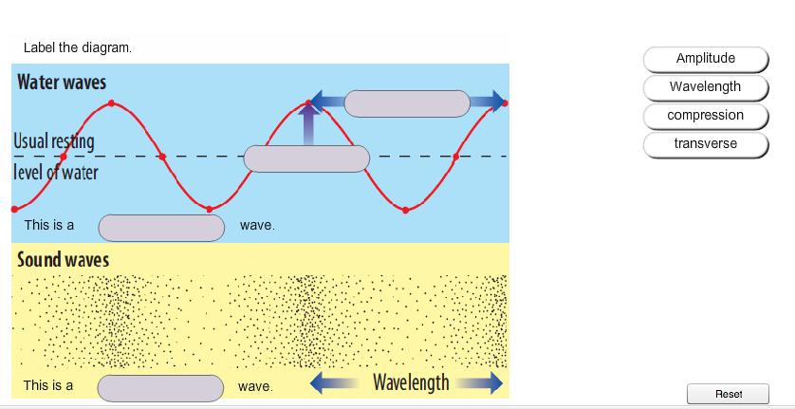

(b) Which of these (transverse or longitudinal) describes a light wave? (1 mark)

2. Draw the path of the rays in the following diagrams. (5 marks)

3. Label the compressions and rarefactions in the diagram below. (2 marks)

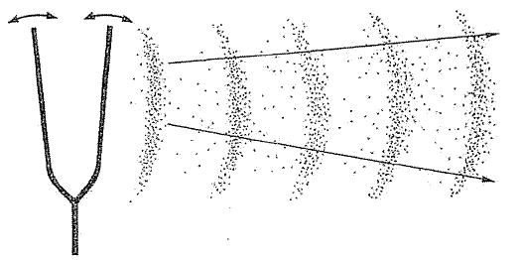

4. (a) Complete the diagram of the electromagnetic spectrum by naming the remaining bands. Choose from the following terms. (4 marks)

ultraviolet microwave infrared gamma ray

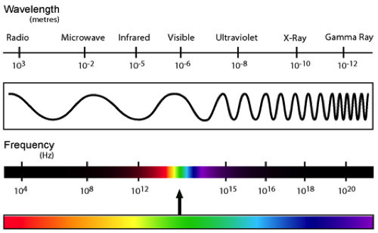
C
D
A
B

A: B:

C: D:

